|  |
| --- |
| Zopa Loan Quotation Test Plan |
|  |
|  |
| Zopa |
|  |
|  |
|  |
| Prepared by: Sonia Khetarpal |
|  |
| Version Number: 0.1  Date of Issue: 01st May 2018 |

##### Document History

|  |  |  |
| --- | --- | --- |
| Version No | Date | Notes |
| 0.1 | 01/05/2018 | Initial Draft |
|  |  |  |
|  |  |  |
|  |  |  |
|  |  |  |
|  |  |  |
|  |  |  |

##### Related Documents

|  |  |  |
| --- | --- | --- |
| Reference | Name | Notes |
| 1 | SeleniumTest.doc | This is a document received and available for view |
| 2 |  |  |
| 3 |  |  |
| 4 |  |  |
| 5 |  |  |
| 6 |  |  |
| 7 |  |  |
| 8 |  |  |
| 9 |  |  |
| 10 |  |  |
| 11 |  |  |

##### Reviewers

|  |  |  |
| --- | --- | --- |
| Name | Organisation | Role |
|  |  |  |
|  |  |  |
|  |  |  |
|  |  |  |
|  |  |  |
|  |  |  |
|  |  |  |
|  |  |  |
|  |  |  |

##### Authorisation

|  |  |  |
| --- | --- | --- |
| Name | Organisation | Role |
|  |  |  |
|  |  |  |
|  |  |  |
|  |  |  |

Contents

1 Introduction 5

1.1 Background 5

1.2 Purpose and scope of this document 5

2 Project Context 6

2.1 Business processes subject to Integration & Acceptance Testing 6

2.2 Integration & UAT Schedule 11

3 Test Approach 12

3.1 Overall Approach 12

3.2 Integration testing 12

3.3 User Acceptance Testing 14

3.4 Test Automation 16

3.5 Testing Roles and Responsibilities 16

3.6 Tooling 19

3.7 Environments 20

3.8 Defect Management 20

4 Entry/Exit Criteria 22

4.1 Entry Criteria assessment process 22

4.2 Exit Criteria assessment process 22

Appendix A 23

# Introduction

## Background

The Zopa Loan functionality will enable a new borrower complete sign up flow to get loan quotation.

# Project Context

**In scope elements**

The following components are in scope of the Testing.

* Complete the sign up flow as a new borrower at zopa

### Out of scope elements

The following components are out of scope of the Testing.

## Functionality Testing Schedule

In general:

The following table provides the key schedule milestones. The low level details will be determined closer to the time of test execution and will provide a breakdown of the order of the tests to be completed per day within the test phase:

|  |  |  |
| --- | --- | --- |
| Task / Milestone | Start | End |
| Issue Final version of Test Plan |  |  |
| Issue Final version of Integration Test Scenarios |  |  |
| Receive UAT Checklists |  |  |
| Receive UAT Test Data |  |  |
| Complete Integration Test Scripts |  |  |
| Complete Test Automation Framework |  |  |
| Complete Automation batch scripts |  |  |
| Drop 7 to UAT |  |  |
| Initial load of reference data |  |  |
| Integration Entry Gateway |  |  |
| Integration - Cycle 1 |  |  |
| Integration - Bug Fix 1 |  |  |
| Integration - Cycle 2 |  |  |
| Integration - Bug Fix 3 |  |  |
| Integration - Cycle 3 |  |  |
| Integration Exit / UAT Entry Gateway |  |  |
| UAT Execution - Cycle 1 |  |  |
| UAT Bug Fix |  |  |
| UAT Execution - Cycle 2 |  |  |
| Issue final Integration & Acceptance Completion Report |  |  |
| Integration & Acceptance Gateway |  |  |
|  |  |  |

# Test Approach

## Overall Approach

## Test Automation

A test automation framework(BDD Cucumber) will be developed to support a data driven approach. The framework will interact with the Zopa systems to perform the functionality testing of signing up the workflow for a new borrower to get a quotation.

### Test data automation

## Testing Roles and Responsibilities

|  |  |  |
| --- | --- | --- |
|  |  |  |
|  |  |  |
|  |  |  |
|  |  |  |
|  |  |  |
|  |  |  |
|  |  |  |
|  |  |  |
|  |  |  |

## Tooling

The following tools will be utilised to support Test Management, Defect Management and Test Data Preparation and Test Execution:-

### Tooling required for connectivity to AWS system components

* Eclipse IDE
* Maven

### Tooling required for Test & Defect Management

HP ALM will be used for Test and Defect Management.

## Environments

## Defect Management

The Test Strategy proves a comprehensive overview of the defect management process. Entry/Exit Criteria

## Entry Criteria

## Exit Criteria

**Metrics**

Number of Scenarios Ran 4

Number of Scenarios Passed 4

Number of Scenarios Failed 0

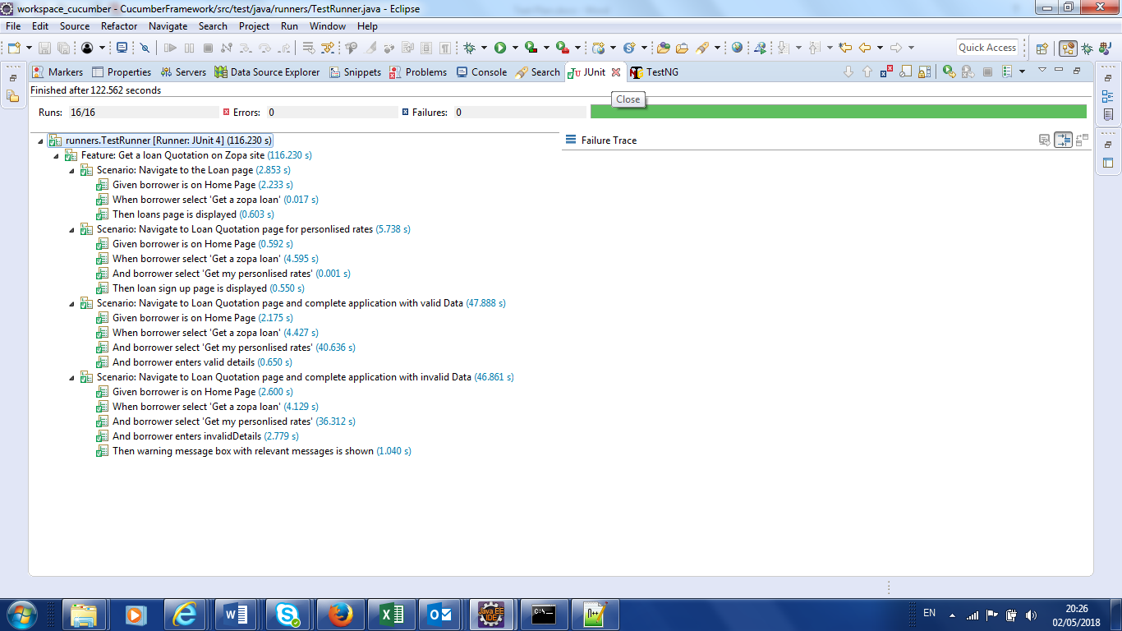

# Appendix A

# Appendix B

End of Document